STEP FOR INSTALL AND RUN XAMPP SERVER

STEPS FOR DOWNLOAD AND INSTALL XAMPP

STEP 1

In this tutorial, we will use the latest, XAMPP 1.7.4, version of the tool.

**Downloading XAMPP Installer**

First of all, open the [XAMPP 1.7.4](http://www.apachefriends.org/en/xampp-windows.html#641) page (***Figure 1***). The page shows a list of bundled tools

(1). In the **Download** section (2), click **XAMPP**  (3), because we do not need add-on packages.

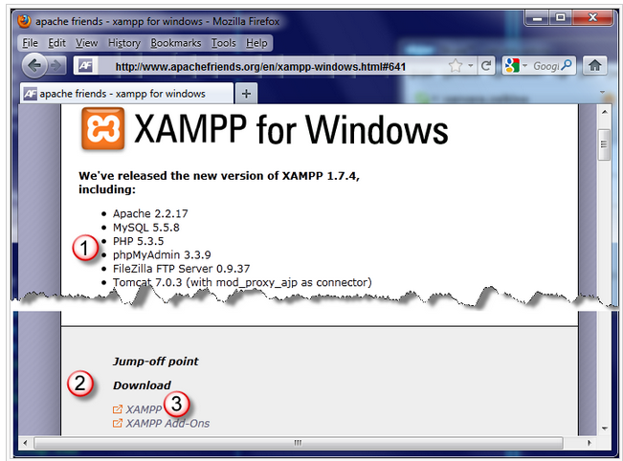

STEP 2

Upon clicking the **XAMPP** link, you are brought to the XAMPP download page (***Figure 2***). Here we will choose what to download depending on the installation method. The list of packages available for download (1) shows two installation strategies:

1. Download an installation executable file and run it to have all the XAMPP folder structure set up and populated automatically.
2. Download an archive, extract the XAMPP files, then run the "setup_xampp.bat file to set up XAMPP in your system.

Let's choose the easiest way and choose **Installer** (2) to have all done automatically.

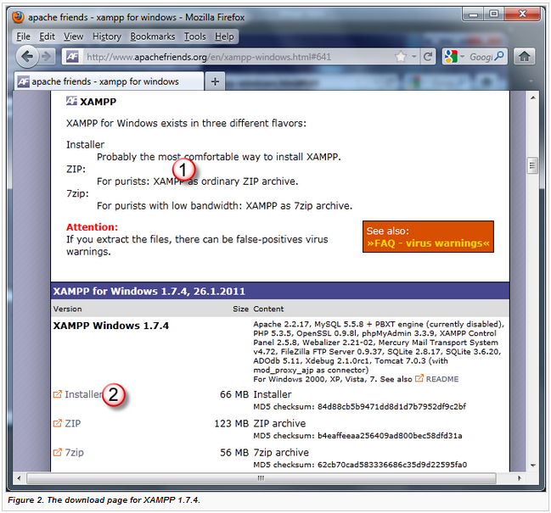

STEP 3

When you click the **Installer** link, the start download page opens (***Figure 3***) where the count-down start.

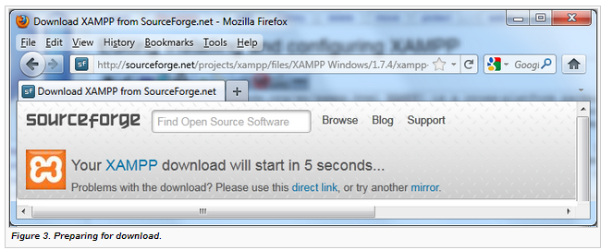

STEP 4

In five seconds, the download dialog box (***Figure 4***) opens informing you that the installation executable file (2) is going to be downloaded. Click **Save** (2) to start the download.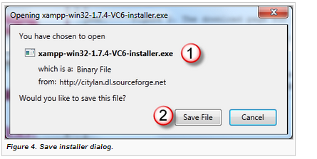

STEP 5

Upon clicking **Save**, the **Downloads** (***Figure 5***) dialog box opens showing the download progress graphically in the progress bar (1).

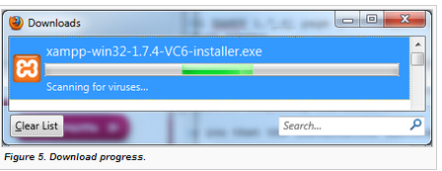

STEP 6

When the installer is downloaded and checked for viruses successfully, the progress bar disappears (***Figure 6***). To initiate XAMPP installation, click the downloaded installation executable file (1) twice.

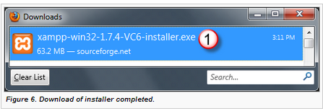

STEP 7

The **XAMPP Installation Wizard** starts.

***Note***: For Windows Vista and Windows 7 a warning is displayed (***Figure 7***) advising not to install XAMPP under the Program Files folder:

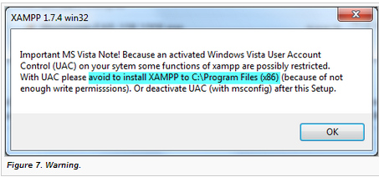

STEP 8

The first, **Welcome**, page (***Figure 8***) of the wizard recommends (1)that you close other applications before setting up XAMPP to enable updating system files, if necessary. Click **Next** (2), when ready

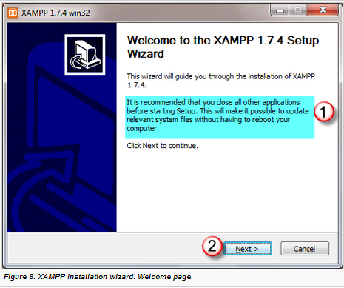

STEP 9

Upon clicking **Next**, the **Choose Install Location** (***Figure 9***) page opens

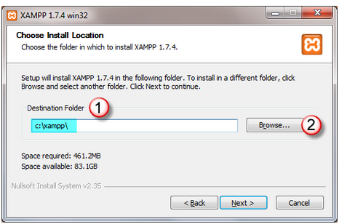

STEP 10

In the **Destination Folder** (1) text box, specify the path to the folder where you want XAMPP installed. The text box already shows the default location c:/xampp. You can change it by clicking the **Browse** button (2) and choosing another location in the dialog box that opens. However, in this tutorial let's accept the suggested default location. Click **Next** to pass on to the **XAMPP Options** (***Figure 10***) page.

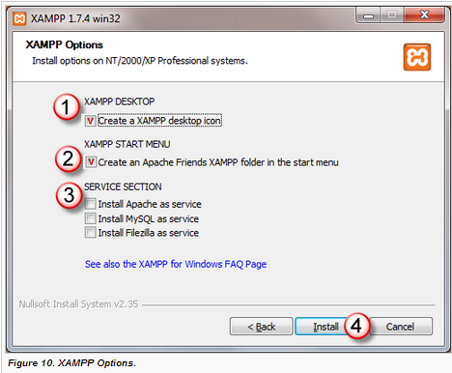

STEP 11

Now let's decide how the Apache Web server and the MySql database server will be launched. This can be done automatically, upon the operating system start, or manually, through the XAMPP Control Panel.

If you prefer to have a component start automatically, set it up as service by selecting the **Install as service** check box next to the component name in the **Services** section (3). However, in this tutorial, let's leave the check boxes clear to practice working with the Control Panel.

Finally, define the way to access the XAMPP Control Panel:

* By clicking the dedicated desktop icon. To have the icon created, select the **Create a XAMPP desktop icon** check box (1).
* Through the dedicated menu command. To have the4 command added to the Start menu, select the **Create an Apache Friends folder in the Start menu** check box (2).

When you click **Install** (4), the Wizard brings you to the next, **Installing**, page (***Figure 11***) where you can monitor the installation process in the progress bar (1).

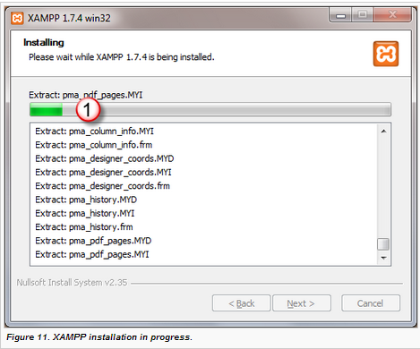

STEP 12

When the installation is completed successfully, click **Next** to pass on to the last page of the Wizard (***Figure 12***).

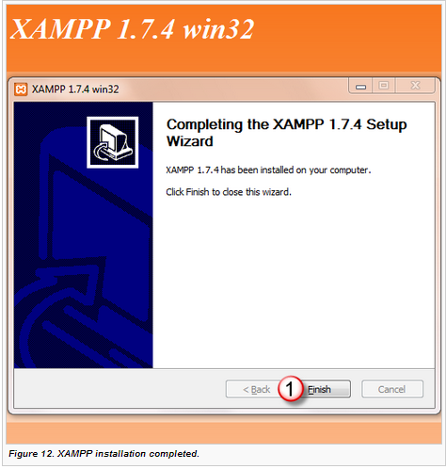

STEP 13

The page informs you that XAMPP has been installed successfully. When you click **Finish** (1), the Wizard closes and the XAMPP information dialog box opens (***Figure 13***).

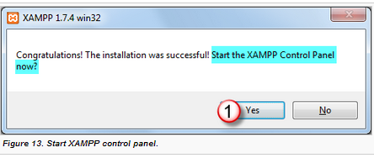

In this dialog box, XAMPP asks whether you want to open its Control Panel right now. Let's agree and click **Yes** (1).

STEP 14

During the installation [we decided not to set up XAMPP components as services](http://wiki.jetbrains.net/intellij/Installing_and_configuring_XAMPP#do_not_set_up_components_as_services), so they are handled through the XAMPP Control Panel. At the last step, we also [agreed to open the XAMPP Control Panel](http://wiki.jetbrains.net/intellij/Installing_and_configuring_XAMPP#agreed_no_open_panel). Now it's time to see how the XAMPP Control Panel will help us.

#### Starting and Stopping XAMPP Components

First of all, let's start the Apache and the MySql servers, which are obviously inactive when the XAMPP control panes opens upon the installation completion (***Figure 14***).

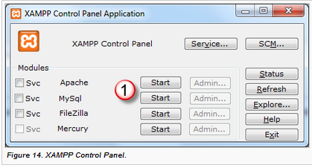

STEP 15

To start the servers, click the **Start** buttons (1) next to them.

As you can see from ***Figure 15***, the status has changed to **Running** (1) and the titles of the buttons are now **Stop** (2)

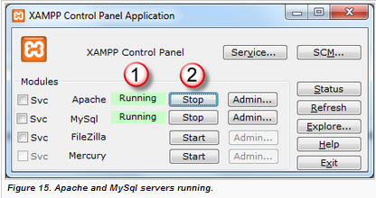

***Note:*** If the Apache server does not start, this means that its default port 80 is already busy. Most likely, it is Skype. To solve the problem without changing the default XAMPP settings is to close Skype or just set the status to **Offline**. The start the Apache server and activate Skype, when ready. Skype will find another free port to listen to.

STEP 16

AFTER INSTALLATION COMPLETE , NOW WE HAVE TO RUN ONE PHP FILE ON WEB

“GO TO C/XAMPP/htdocs/ “ and paste your php file in htdocs folder

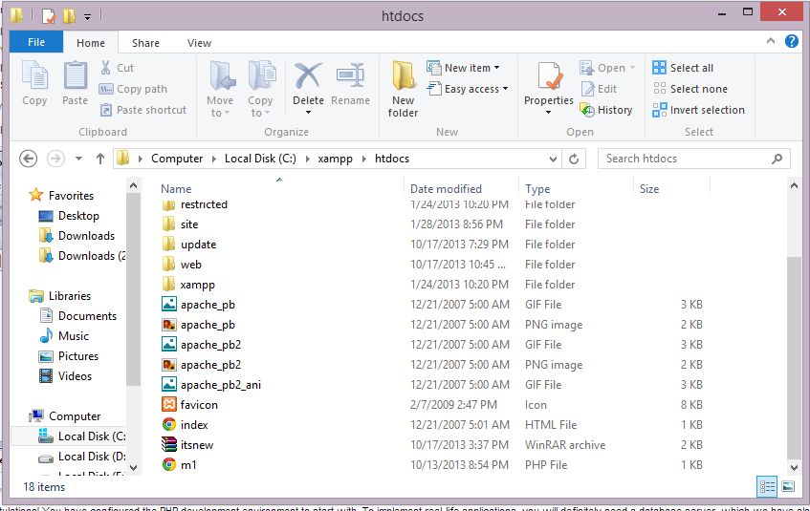

STEP 17

NOW RUN THAT PHP FILE ON XAMPP SERVER LOCALHOST

GO TO WEB BROWSER AND WRITE localhost/m1.php

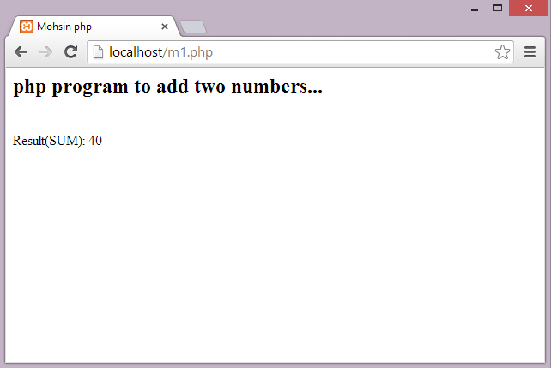

PHP FILE RUN COMPLETELY AND SHOWING THE OUTPUT .

IT MEANS YOUR XAMPP SERVER INSTALL SUCESSFULLY .

**(H.P)**